Progress Report on App Development (Week 03)

-by Ritesh Kumar

An Intern in UpSkill Campus, 05/07/2023

Ritesh Kumar

I am pleased to present you with a comprehensive report on app development (Week 03), which provides an overview of “A Temperature Converter Android App” with the process, challenges, and best practices for successful app development. This report aims to make understanding of the key aspects of app development and making informed decisions in this domain.

**Progress Report on App Development (Week 03)**

# An Overview on App Development

In the 3rd week of “6 Weeks of App Development – Project-Based Learning”. Temperature Converter Application is built using android studio where temperature entered in Celsius can be converted to Fahrenheit. Note that we are going to implement this project using the **Java** language.

Let’s move toward the project

* A Temperature Converter Android App

## Content:

* Create a New Project
* Working with the activity_main.xml file
* Working with the MainActivity.java file
* Source Code
* Output

### Challenges and Hurdles:

* **Use different colours in your android app**
* **Using the Snackbar for the output**
* **Writing some simple logic for simple math calculation**
* **Toast in Android**

#### Lesson Learned:

* **A Temperature Converter Android App**

We are going to implement this project using the **Java**language.

**Step By Step Implementation of Project 3:**

**Step 1: Create a New Project**

To create a new project in Android Studio please refer to How to Create/Start a New Project in Android Studio. Note that select Java as the programming language. Drag and drop the template image to drawable.

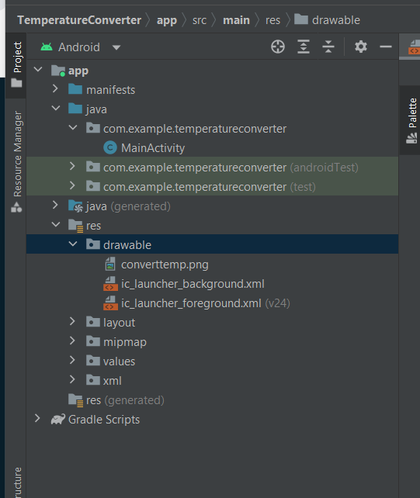

**Step 2: Adding new colors to the colors.xml file**

Navigate to the **app > res > layout > activity_main.xml**and add the below code to that file. Below is the code for the **activity_main.xml** file. Create an [ImageView](https://www.geeksforgeeks.org/imageview-in-android-with-example/), [TextView](https://www.geeksforgeeks.org/working-with-the-textview-in-android/), and [EditText](https://www.geeksforgeeks.org/edittext-widget-in-android-using-java-with-examples/)by adding respective constraints. We have to add an**ImageView**to display an image or resource in an application, **TextView** to show the text for the user, an **EditText** for input, and a **Button** for converting degrees Celsius to Fahrenheit. In EditText, select Number(Decimal) to get only numbers on the keyboard.

**Xml**

<?**xml** version="1.0" encoding="utf-8"?>

<**androidx.constraintlayout.widget.ConstraintLayout**

    xmlns:android="<http://schemas.android.com/apk/res/android>"

    xmlns:app="<http://schemas.android.com/apk/res-auto>"

    xmlns:tools="<http://schemas.android.com/tools>"

    android:layout_width="match_parent"

    android:layout_height="match_parent"

    tools:context=".MainActivity">

    <**ImageView**

        android:id="@+id/imageView"

        android:layout_width="wrap_content"

        android:layout_height="wrap_content"

        android:layout_marginBottom="180dp"

        app:layout_constraintBottom_toBottomOf="parent"

        app:layout_constraintStart_toStartOf="parent"

        app:srcCompat="@drawable/converttemp" />

    <**TextView**

        android:id="@+id/textView"

        android:layout_width="wrap_content"

        android:layout_height="wrap_content"

        android:layout_marginStart="80dp"

        android:layout_marginLeft="80dp"

        android:layout_marginTop="8dp"

        android:text="Enter the value in Celsius"

        android:textAppearance="@style/TextAppearance.AppCompat.Large"

        app:layout_constraintStart_toStartOf="@+id/imageView"

        app:layout_constraintTop_toBottomOf="@+id/imageView" />

    <**EditText**

        android:id="@+id/editTextNumberDecimal"

        android:layout_width="wrap_content"

        android:layout_height="wrap_content"

        android:layout_marginStart="20dp"

        android:layout_marginLeft="20dp"

        android:layout_marginTop="12dp"

        android:ems="10"

        android:hint="the value in Celsius"

        android:inputType="numberDecimal"

        app:layout_constraintStart_toStartOf="@+id/textView"

        app:layout_constraintTop_toBottomOf="@+id/textView" />

    <**Button**

        android:id="@+id/button"

        android:layout_width="wrap_content"

        android:layout_height="wrap_content"

        android:layout_marginBottom="24dp"

        android:onClick="OnConverterClick"

        android:text="Convert"

        app:layout_constraintBottom_toBottomOf="parent"

        app:layout_constraintEnd_toEndOf="parent"

        app:layout_constraintHorizontal_bias="0.498"

        app:layout_constraintStart_toStartOf="parent" />

</**androidx.constraintlayout.widget.ConstraintLayout**>

After writing the code of the XML file for the app, the design looks as follows.

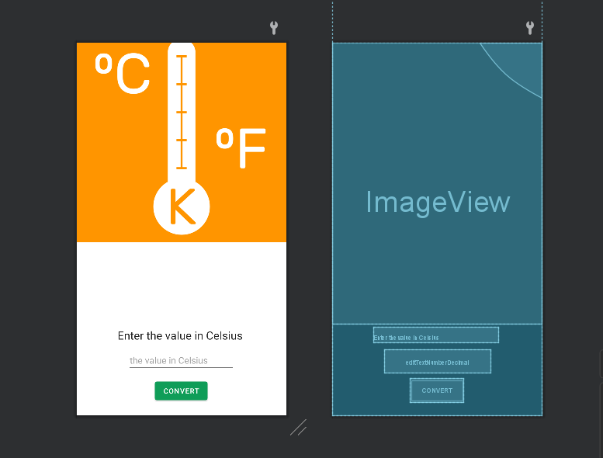

**Step 3: Working with the activity_main.xml file**

Go to the **MainActivity.java** file and refer to the following code. Below is the code for the **MainActivity.java** file. In this file, write a code to get the user’s text entered and converted to Fahrenheit. The text entered by the user is stored as a string and it should be converted to double by using **Double.parseDouble(inputInString**) function. And use the formula mentioned above to get the output in Fahrenheit. The output is displayed in Snackbar.

**Java**

**package** com.example.temperatureconverter;

**import** androidx.appcompat.app.AppCompatActivity;

**import** android.os.Bundle;

**import** android.view.View;

**import** android.widget.EditText;

**import** com.google.android.material.snackbar.Snackbar;

**public** **class** MainActivity **extends** AppCompatActivity {

**public** **void** OnConverterClick(View view){

        EditText editText = findViewById(R.id.editTextNumberDecimal);

        String inputInString = editText.getText().toString();

        Double inputInDouble = Double.parseDouble(inputInString);

        Double outputInFahrenheit = (inputInDouble*9/5)+32;

        Snackbar.make(view, "Temp in" +inputInDouble + "celsius is" +outputInFahrenheit

                      + " in Fahrenheit",Snackbar.LENGTH_LONG).show();

    }

    @Override

**protected** **void** onCreate(Bundle savedInstanceState) {

**super**.onCreate(savedInstanceState);

        setContentView(R.layout.activity_main);

}

}

* **The layout of the app:**

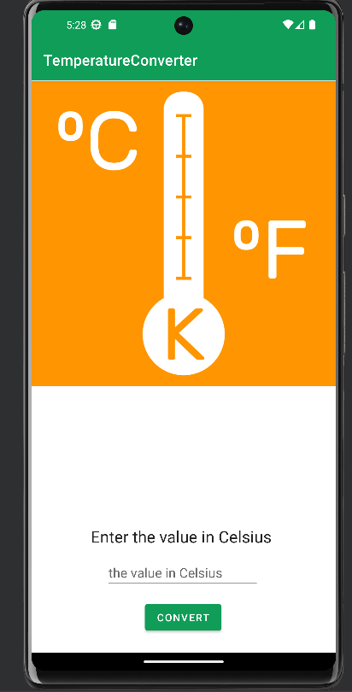

**Output:**

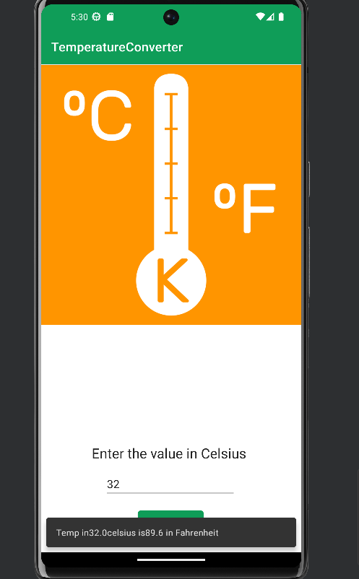

##### **References:**

* <https://developer.android.com/studio>
* https://developer.android.com/
* <https://www.geeksforgeeks.org/>

Please note that this report provides a general overview of app development, and specific recommendations or strategies should be tailored to your organization's unique requirements and goals. Should you require further assistance or have any questions, please do not hesitate to contact me.

Thank you for the opportunity to prepare this report, and I hope it proves valuable in your app development endeavors. I look forward to discussing this topic further and assisting you in your future projects.

Sincerely,

Ritesh Kumar (9330771068)

Email: kumarritesh6769@gmail.com